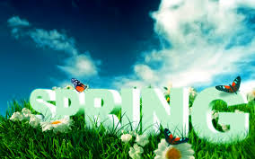

* Sponsored by: English IV Students

# 1. District-wide Poetry Contest "Spring Fun" for ALL UNITY STUDENTS.

# 2. Deadline for entry: March 6, 3:05 pm.

# 3. Submit two (2) titled copies: one with name, age, grade and teacher's name in upper right corner, one without

# 4. Prizes for Top 3 in each division: 1st = $50, 2nd = $30, 3rd = $20

# 5. Divisions are K-1st, 2nd-4th, 5th-8th, 9th-12th

# 6. Top 3 in each division announced March 20th

# 7. Top 3 in each division perform at "Poetry Slam" April 7th at 7:00 pm

# 8. Each participant will earn a "Spring Fun" Poetry Collection book with ALL ENTRIES published in it.

# 9. Poems can have artwork accompany them for "Most Visually Creative" Poem Certificate.

# 10. Artwork can be submitted for the Cover Design Contest. Winner in each division will be placed on the cover. All participants will be added to the book in the "Artwork" section.

# 11. Direct all questions to [poetry@cusd4.com](mailto:poetry@cusd4.com). All submissions preferred electronically, but will be picked up at each building in the district.

Email: poetry@cusd4.com

Poetry Contest Rules