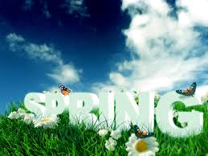

Art & Poetry Contest

Open to all Unity School District 4 students

## Deadline: March 6, 2015

The contest is free to enter. The top 3 in each division will perform at the Poetry Slam on April 7 at 7 P.M. Each participant will earn a poetry collection book for his or her submission.   
For all official rules and more information, email poetry@cusd4.com or visit: <http://cusd4shirey.weebly.com/unity-district-wide-poetry-contest.html>.

# Prize: 1st: $50 2nd: $30 3rd: $20

# Divisions: K-1st, 2nd-4th, 5th-8th, 9th-12th