GENERAL INSTRUCTIONS: Please fill out the header with the appropriate information. Use the words learned in the corresponding Vocabulary Definitions to complete the assignment below.

Eng. IV- Vocabulary Lesson 11 Worksheet
DIRECTIONS: Using each of your vocabulary words, write them in the boxes that match the definition numbered below. On the blank, write the part of speech.
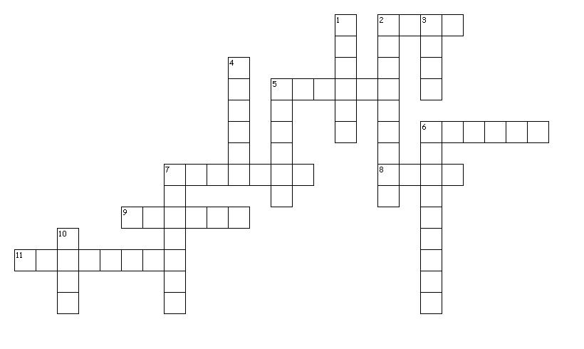
Across
2. _____ - a large hook
5. _____ - to distort; to confuse
6. _____ - well-versed; abled to speak/write clearly
7. _____ - beginning; origin; creation
8. _____ - manner of walking
9. _____ - loud quarrel
11. _____ - glaringly bad; outrageous

Down
1. _____ - minor weakness; fault
2. _____ - family history; lineage
3. _____ - constant state of motion
4. _____ - useless; ineffectual; unnecessary
5. _____ - a strategy; opening maneuver
6. _____ - trivial; silly
7. _____ - horrible; frightful; hideous
10. _____ - to stare with an open mouth

DIRECTIONS: Using each of your vocabulary words ONCE, write them on the lines for each sentence that it fits best with. In the parentheses, write the part of speech.

- My life is in a constant state of __________________________ (_____); I never know what is going to happen next.
- Let’s start at the __________________________ (_____): it all starts with this _________________________ (_____) I have for not being able to say, “No!”
- It seems __________________________ (_____) for me to even try.
- Nonetheless, I’ve done my research and traced this trait back through my __________________________ (_____).
- The discovery __________________________ (_____) my idea that my family had it all together.
- When I found out how busy my entire family was, my mouth __________________________ (_____).
- This __________________________ (_____) act left her even more vulnerable to outside influence.
- It wasn’t __________________________ (_____) knowledge, but it wasn’t wonderful news either.
- I was surprised to find that my great-great grandfather was a champion fisherman; he even made his own rod and __________________________ (_____) for his competitions.
- I also learned my great-great grandmother was __________________________ (_____) in several languages, including German, English, and Spanish.
- She actually was a part of the government __________________________ (_____) to incorporate interpreters into their international embassies.
- Therefore, I began to change my __________________________ (_____) to one of a less-speedy pace.
- I didn’t want to cause a __________________________ (_____) with my family, but I didn’t want to just let this knowledge sit.
- So, I came up with a __________________________ (_____) to discuss the matter with them that evening.
- It was simple: I would make small talk first instead of accusing them in a __________________________ (_____) manner. I wished it would work.

