GENERAL INSTRUCTIONS: Please fill out the header with the appropriate information. Using the words from unit one, fill in the blanks in the puzzle to solve for the definitions.

Vocabulary Lesson #1 Activity
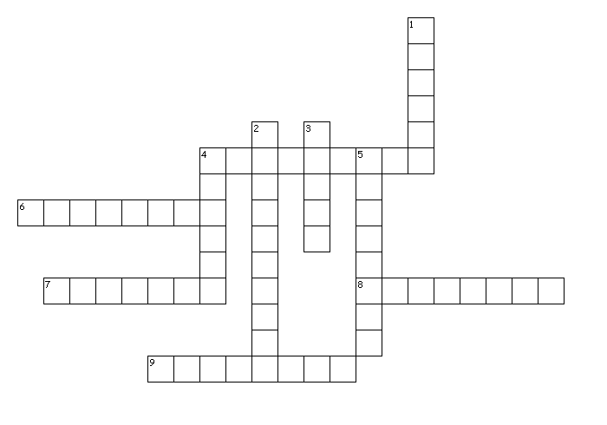
Across
4. ____ an associate or partner
6. ____ to warn or caution
7. ____ a subordinate or assistant
8. ____ liveliness, willingness, or eagerness
9. ____ to make others unfriendly to you
Down
1. ____ to hint at or refer to
2. ____ anything causing great suffering
3. ____ reserved or distant
4. ____ feeling great dismay or horror
5. ____ to recommend or speak in favor of
GENERAL INSTRUCTIONS: Please fill out the header with the appropriate information. Use the words learned in Lesson 1 Vocabulary to best fill in the blanks of the assignment below along with the part of speech in the parentheses.

- The _______________________________ (______) talked with his _______________________________ (______) in order to discuss the _______________________________ (______) they felt for the classes they taught at the college. They knew it was going to be a great year!
- He _______________________________ (______) his friends that the ride “The Haunted Cave” would cause an _______________________________ (______) reaction. The title alone _______________________________ (______) to fear and scary memories he had as a child.
- The bully _______________________________ (______) all his friends because he treated others so poorly. His actions had caused so much _______________________________ (______) and pain that he became a hermit, _______________________________ (______) from all of society. He left himself alone; no one would _______________________________ (______) his work to others because of his ill-treatment of others in his past.

