GENERAL INSTRUCTIONS: Please fill out the header with the appropriate information. Use the words learned in Unit 2 Vocabulary to complete the assignment below.

Eng I - Vocabulary Lesson 4 Worksheet
DIRECTIONS: Match the definition to each of your vocabulary words. Take the letters that appear in boxes and unscramble them for the final message. In the parentheses, write the part of speech.
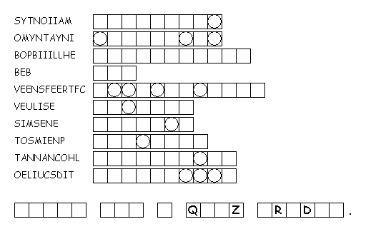
- __________________ (______) hatred or hostility shown openly
- __________________ (______) the condition of being anonymous; unknown
- __________________ (______) one who love books
- __________________ (______) to flow or fall back, as with the tide
- __________________ (______) high-spirited, lively
- __________________ (______) tending to avoid; hard to capture
- __________________ (______) anyone or anything that causes another’s downfall
- __________________ (______) favoritism shown by people in high places toward their relatives
- __________________ (______) carefree; casually unconcerned
- __________________ (______) the state of showing concern or care
FILL IN THE BLANK DIRECTIONS: Please fill out the header with the appropriate information. Use the words learned from Vocabulary Lesson 3 to best fill in the blanks of the assignment below along with the part of speech in the parentheses.

- The _______________________________ (______) was not moved by the _______________________________ (______) shown from non-readers. You could say he was _______________________________ (______) in regard to others’ opinions of him. On the contrary, though, reading made him _______________________________ (______) and excited for the next book to be released.
- The _______________________________ (______) of the _______________________________ (______) was soon no secret. Instead, he showed no _______________________________ (______) when it came to people discovering his identity. He only wanted people to know that his goal was the destruction of all heroic figures.
- Many powerful people are often accused of _______________________________ (______) for hiring their children; something that can be quite _______________________________ (______) and void of any real consequences. The constant shuffle of people _______________________________ (______) like the tide..

