READ THE ACTIVITY DIRECTIONS: Using your vocabulary words, unscramble each of the clue words to spell them correctly. Copy the letters in the numbered cells to other cells with the same number. Fill in the part of speech and definition below. Page 1.

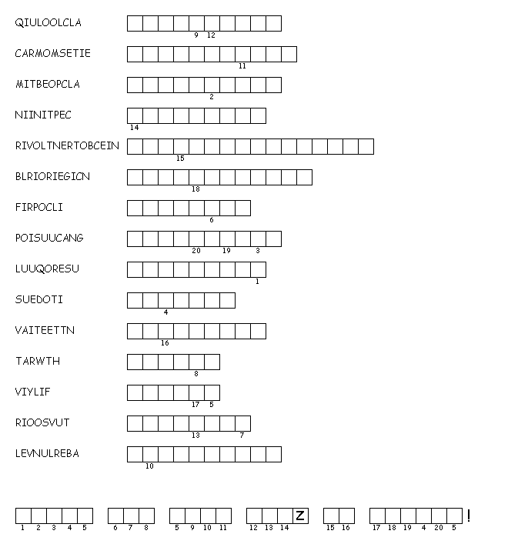
1. (____): ____________________________________
2. (____):____________________________________
3. (____):____________________________________
4. (____):____________________________________
5. (____):____________________________________
6. (____):____________________________________
7. (____):____________________________________
8. (____):____________________________________
9. (____):____________________________________
10. (____):____________________________________
11. (____):____________________________________
12. (____):____________________________________
13. (____):____________________________________
14. (____):____________________________________
15. (____):____________________________________
Turn over to the back – worksheet continued there!

DIRECTIONS: Use the words you’ve studied and those from this word search to complete the sentences below. Page 2.

- I will try to put this in as _________________________ (____) terms as possible.
- When children are in an _________________________ (____) stage of development, they tend to make many mistakes and missteps and are _________________________ (____) to outside influence.
- Some are child-_________________________ (____) and go on to great musical careers.
- Others can be _________________________ (____) and even _________________________ (____) about responsibilities they have.
- Sometimes, they even try to _________________________ (____) their parents because they don’t want to do their chores.
- The _________________________ (____) behavior makes for a stand-still with their parents, as neither wants to give in to the other.
- Many parents make themselves seem _________________________ (____) and irrefutable.
- Both sides want to _________________________ (____) the other’s motives, but usually the parents win.
- Fortunately, for their parents, this time in their life is _________________________ (____).
- Can you _________________________ (____) with either side?
- It may seem like a _________________________ (____) process to understand parents and children and their motives.
- Therefore, don’t be _________________________ (____) like rabbits.
- Instead, try to be _________________________ (____) with everyone around you and understanding of their situation; it will help in the long run!

GOOD LUCK THIS WEEK! STUDY FOR YOUR QUIZ ON FRIDAY!

