GENERAL INSTRUCTIONS: Please fill out the header with the appropriate information. Use the words learned in the corresponding Vocabulary Definitions to complete the assignment below.

Eng I - Vocabulary Lesson 11 Worksheet
DIRECTIONS: Using each of your vocabulary words, write them in the boxes that match the definition numbered below. On the blank, write the part of speech.
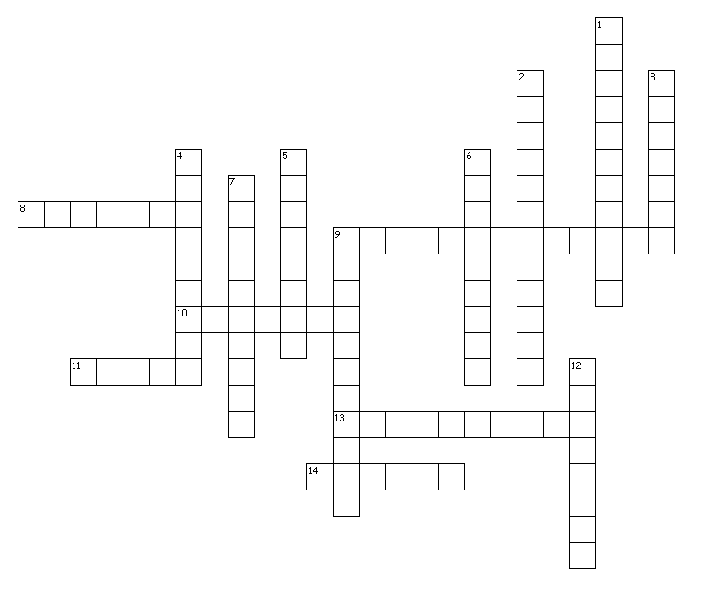
Across
8. _____ - to presume; to guess; to conclude w/o proof
9. _____ - stealthy; sneak; secretive
10. _____ - corrosive; poisonous; able to burn or eat away
11. _____ - reverence; devotion to religion
13. _____ - a rebel; a person who opposes pop. ideas
14. _____ - calm; peaceful; serene

Down
1. _____ - similar
2. _____ - insincere; false
3. _____ - pretentious; self-important; narcissistic
4. _____ - a ranking system
5. _____ - to verify; to make official
6. _____ - delicious; luxurious; grand; expensive
7. _____ - to surrender
9. _____ - prone to; easily affected by; gullible
12. _____ - a substance that speeds up a reaction

DIRECTIONS: Using each of your vocabulary words ONCE, write them on the lines for each sentence that it fits best with. In the parentheses, write the part of speech.

- Because she was __________________________ (_____) to allergic reactions, her parents never let her eat anything that they did not approve beforehand.
- She quickly learned that her disease was genetic, caused from __________________________ (_____) alleles from both parents genetic code.
- They found that eating out was __________________________ (_____) to their daughter’s health and would only be a __________________________ (_____) for illness.
- Furthermore, they __________________________ (_____) the only way to keep their daughter healthy was to not let her leave the house.
- Therefore, the daughter began a __________________________ (_____) plot to leave the house.
- This __________________________ (_____) act left her even more vulnerable to outside influence.
- She didn’t want to become an __________________________ (_____), but she saw no other way to prove her point.
- This act was definitely not founded in __________________________ (_____) for her parents but rather in self-satisfaction.
- One night she told her parents she was staying a friend’s house: a __________________________ (_____) statement, as she was actually going out with some others.
- She actually felt __________________________ (_____) because she experienced food and freedom for the first time even though it was in defiance of her parents.
- Meanwhile, her parents planned to surprise her at her friend’s house, but soon became much the opposite of __________________________ (_____) at the revelation that she had deceived them.
- While she was out enjoying a __________________________ (_____) dinner with friends, her parents waited with worry and fear.
- The teenager finally __________________________ (_____) to the evening after filling her stomach of gourmet delicacies.
- Upon arrival at her home, she discovered the true meaning behind the __________________________ (_____) in her house: she was low man on the totem pole for the next three years of high school.

