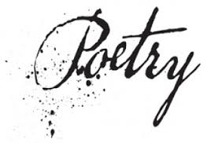
Contest Guidelines 2017:

Type of poem:

- No length or specific types
- No theme - Anything goes, but it must be school appropriate

Details about submission:

- Submissions should be typed, double spaced, and in 12-point legible fonts.
- 2 copies submitted: 1 with name, age, & division, 1 without name, but has division
- Artwork and/or poems may be submitted; each must be original work. Plagiarism will result in automatic disqualification.
- Submissions preferred electronically, but can be accepted through the school or teacher

Details about Winners:
- Winners announced March 24, 2017.
- "Most Creative" Award given for poetry with artwork
- Prizes for poetry (in ea. DIV): 1st = $50, 2nd = $30, 3rd = $20 Prizes for Artwork (in ea. DIV): Winner = $25
- Top 3 in ea. DIV will perform at Poetry Slam on April 11th, 6 pm when winners will be announced.

Specifics about Contest:
- Each participant will earn a contest book for submission, complete with winners and all district submissions.
- Open to all Unity School District students at no cost: it’s free to enter
- Deadline: Friday, March 10, 2017 by 3:05 pm (end of school)
- DIVISIONS: Primary - K-1st, Elementary - 2nd-4th, Middle School - 5th-8th, High School 9th-12th

