**GENERAL INSTRUCTIONS**: Please fill out the header with the appropriate information. Use the words learned in the corresponding Vocabulary Definitions to complete the assignment below.

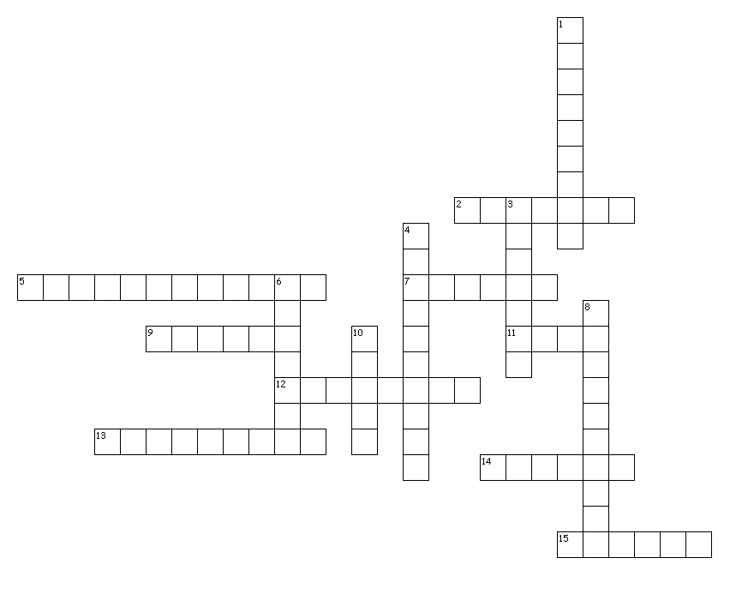DIRECTIONS: Using your vocabulary words, write them in the number of the corresponding boxes (in the crossword) that fits best with the definition. In the parentheses, write the part of speech.

Across

2. (____) a person who lies alone

5. (____) not easily attacked

7. (____) ornate, overtly expensive

9. (____) recklessly ignoring morality

11. (____) to destroy or tear down completely

12. (____) awkward, clumsy

13. (____) condition of weakness

14. (____) lack of supply

15. (____) to snub

Down

1. (____) eager for food

3. (____) hasty, superficial, not thorough

4. (____) extremely large; enormous

6. (____) lazily, slowed, relaxed

8. (____) to weaken

10. (____) vengeance, rage, fury

**GO TO BACK – COMPLETE THE CONTEXT CLUES ASSIGNMENT**

**GENERAL INSTRUCTIONS**: Please fill out the header with the appropriate information. Use the words learned in the corresponding Vocabulary Definitions to complete the assignment below.

DIRECTIONS: Using your vocabulary words and context clues, write the correct word on the lines for each sentence that it fits with best. In the parentheses, write the part of speech.

1. After the publication of *catcher in the Rye*, J.D. Salinger moved to the coutnry where he lived his life as a __________________________ (_____). As a result, he constantly __________________________ (_____) requests for interviews. Since his neighbors in the town refuse to disclose where he lives, his privacy is __________________________ (_____).
2. Because it was one of those __________________________ (_____) afternoons in late summer, Jack fave the report only a __________________________ (_____) look rather than studying it as he should have.
3. The driver had displayed a __________________________ (_____) disregard for the traffic laws which caused hi to be pulled over many times. Once, he was involved in an accident that resulted in injuries that had left him __________________________ (_____) for some time.
4. The architets found it necessary to __________________________ (_____) the building. They wanted to replace this rather austere building with one that was more __________________________ (_____).
5. When the television show reported on the reason for the __________________________ (_____) of food and medicince in the refugee camps, it received a __________________________ (_____) amount of mail.
6. Although Jack usually ate a light lunch, today his appetite was __________________________ (_____). As a result of all he ate and the fact that the coference room was overheated, later that afternoon a feeling of __________________________ (_____) crept over him during an important meeting with his boss. When his head began to nod, his boss shouted at him to wake up. Snappinghis head up, Jack, with an __________________________ (_____) motion of his arm, knoced the water pitcher into his boxx’x lap. That really sparked the __________________________ (_____) of his boss.