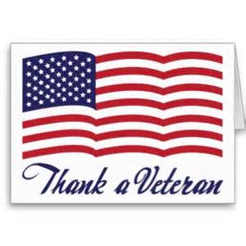
Dear Unity Community:

On Thursday, November 10, 2016, at 9:00 a.m., the Unity Middle and High School students will be honoring our local veterans with a special Veteran’s Day Program. To help prepare for this special event, we need your help. We are inviting all Veterans to this special ceremony. Beginning at 8:00 a.m., we will honor the Veterans and their guests with the opportunity to mingle with other veterans and their families. Students who invited the veterans will be allowed to accompany them during this time of socializing and networking. Please complete the information below if he/she will be able to attend. We need this information by November 4, 2016, in order to prepare for the breakfast and social hour. Please encourage all Veterans to attend. They deserve this recognition.
Name of Veteran Attending, including title (Lt./Major/Cpl./Sgt. First Class John Doe): __________________________________________________
Branch Served in: ______________ Student guest(s): __________________
Years Served & How long ______________________
(i.e. 1978-1980, 2 years): ______________________
________________________________ ______________________
War/Event(s) Served In:
______________________________________________________________________________________________________________________________________
Special Accommodations or Awards Received:
___________________________________________________________________

***Please note: If you have more than one Veteran attending our program, complete one sheet per veteran with the information above. Or visit unityhs.weebly.com or unityms.weebly.com to fill out a form online. Thank you in advance for your assistance and support!

