**GENERAL INSTRUCTIONS**: Please fill out the header with the appropriate information. Use the words learned in the corresponding Vocabulary Definitions to complete the assignment below.

# Eng. IV - Vocab Lesson 10 Worksheet

**PUZZLE INSTRUCTIONS:** Unscramble each of the clue words. Copy the letters in the numbered cells to other cells with the same number. In the space next to each word, write the part of speech and definition.

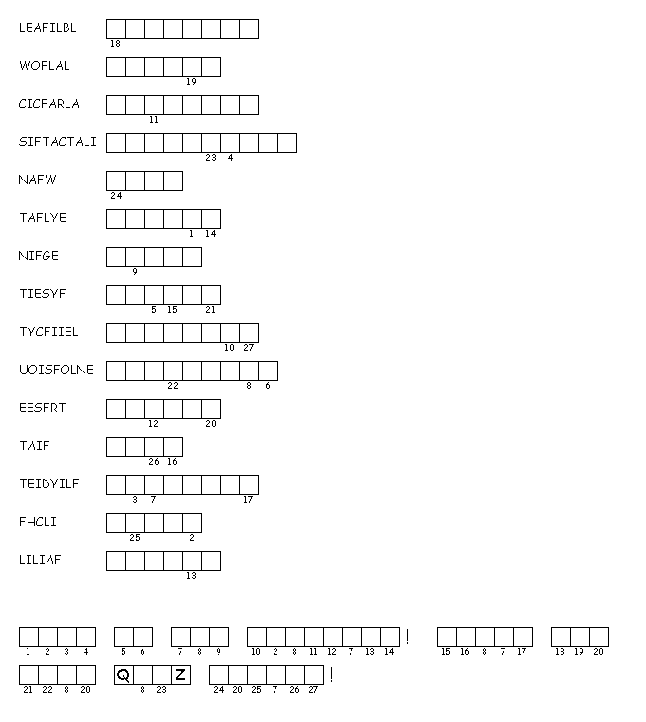

**1.**

**2.**

**3.**

**4.**

**5.**

**6.**

**7.**

**8.**

**9.**

**10.**

**11.**

**12.**

**13.**

**14.**

**15.**

**16.**

DIRECTIONS: Using your vocabulary words, write them on the lines for each sentence that it fits best with. In the parentheses, write the part of speech.

1. A __________________________ (_____) man walked into a store one day.
2. No one knew he was convicted of __________________________ (_____).
3. He was under a __________________________ (_____) not to go into such places where he was tempted to fall back into old habits.
4. Instead, he began a different, yet still __________________________ (_____) act.
5. This time, he __________________________ (_____) to be a store clerk.
6. He __________________________ (_____) over customers while they were shopping and stole their wallets.
7. This drove the __________________________ (_____) of the customer base down along with their __________________________ (_____) for the store.
8. Soon the manager of that store realized he was __________________________ (_____) and decided to take action.
9. Little did he know that the uprising of customers was __________________________ (_____) and growing.
10. Their __________________________ (_____) to the store was beginning to be questioned and they didn’t like it anymore than their belongings being stolen.
11. They began to become __________________________ (_____) with the manager and demanded action be taken.
12. They felt he was a __________________________ (_____) individual with little understanding for their situations.
13. The manager laughed at these __________________________ (_____) allegations and continued with his duties.
14. Finally, he was taken to the store owner, where his __________________________ (_____) time was discussed, and both he and the clerk were released.