**GENERAL INSTRUCTIONS**: Please fill out the header with the appropriate information. Use the words learned in the corresponding Vocabulary Definitions to complete the assignment below.

DIRECTIONS: Using your vocabulary words, unscramble & write them in the boxes below. In the parentheses, write the part of speech. On the following line, write the definition. Then complete the phrase!

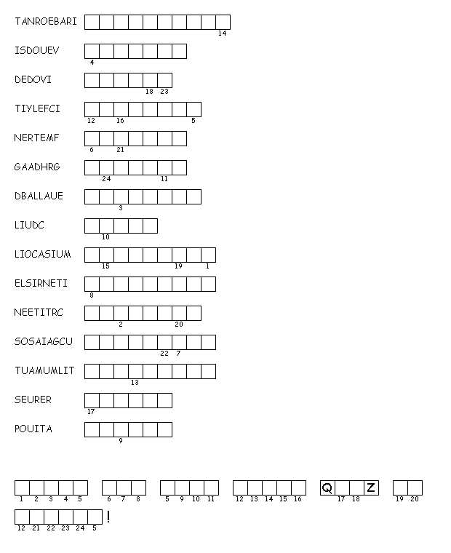

|  |
| --- |
|  |

1. (_____): _____________________________  
   ______________________________________
2. (_____): _____________________________  
   ______________________________________
3. (_____): _____________________________  
   ______________________________________
4. (_____): _____________________________  
   ______________________________________
5. (_____): _____________________________  
   ______________________________________
6. (_____): _____________________________  
   ______________________________________
7. (_____): _____________________________  
   ______________________________________
8. (_____): _____________________________  
   ______________________________________
9. (_____): _____________________________  
   ______________________________________
10. (_____): _____________________________  
    ______________________________________
11. (_____): _____________________________  
    ______________________________________
12. (_____): _____________________________  
    ______________________________________
13. (_____): _____________________________  
    ______________________________________
14. (_____): _____________________________  
    ______________________________________
15. (_____): _____________________________  
    ______________________________________



**DIRECTIONS:** Using your vocabulary words and context clues, write the correct word on the lines for each sentence that it fits with best. In the parentheses, write the part of speech.

1. Despite the good reviews, I found the movie _____________________ (_____) of any humor. I thought the plot was silly and the characters uninteresting. I could not find one _____________________ (_____) thing to say about it.
2. John had a very _____________________ (_____) plan for breaking up Rebecca and Tom. His friends couldn’t believe that even he could be that _____________________ (_____).
3. Although his son became angry when the townspeople called the bank president a _____________________ (_____), Mr. Jones was _____________________ (_____) about responding to their comments.
4. When Johnaon issued his _____________________ (_____) to the town, many people though he was bluffing. Only the more _____________________ (_____) people realized that he would close the plant if the workers did not return to work.
5. While their town was not a _____________________ (_____), the townspeople were a _____________________ (_____) group of people who could bounce back grom misfortune, as long as outsiders did not continually _____________________ (_____) problems among them.
6. While his facial expression usally was marked by smiles and other signs of _____________________ (_____), last night he appeared absolutely _____________________ (_____). Although he gave a very _____________________ (_____) explanation for what he descirbed as a passing condition, one wonders if last night was trulay an _____________________ (_____) or a sign of tough times to come.