GENERAL INSTRUCTIONS: Please fill out the header with the appropriate information. Use the words learned in Unit 2 Vocabulary to complete the assignment below.

Eng I - Vocabulary Lesson 5 Worksheet
DIRECTIONS: Match the definition to each of your vocabulary words. Write the word in the corresponding labeled boxes. In the parentheses, write the part of speech next to the definition below.
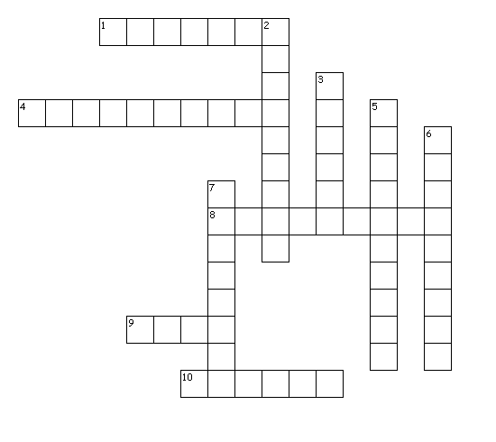
Across
1. (______) To ease, relieve; mitigate.
4. (______) To do away with; to destroy.
8. (______) A bittersweet longing for things of the past.
9. (______) Very dry; parched.
10. (______) Warm or intense feeling; passionate.
Down
2. (______) To dress up or enhance by adding details.
3. (______) A mystery; a riddle.
5. (______) The state of being opposed or hostile to another.
6. (______) A collection of animals.
7. (______) To give rise to; to bring about.

FILL IN THE BLANK DIRECTIONS: Please fill out the header with the appropriate information. Use the words learned from Vocabulary Lesson 5 to best fill in the blanks of the assignment below along with the part of speech in the parentheses.

- The nemesis’ _______________________________ (______) caused an _______________________________ (______) to evolve in his path of destruction: no one could _______________________________ (______) the city’s problems, not even the superheroes.
- Upon visiting the _______________________________ (______), I began to feel _______________________________ (______) for my childhood, remembering the times as if they were yesterday. I’ve always had such _______________________________ (______) feelings for those times!
- While traveling through an _______________________________ (______) climate, the sun _______________________________ (______) any chance for life to grow; the earth did not _______________________________ (______) any hope of vegetation nor plant life. Animals did not _______________________________ (______) the horizon due to the lack of water and plant life.

